**Teen Design Days:**

**Working with Youth to Create Information Technologies & Services**

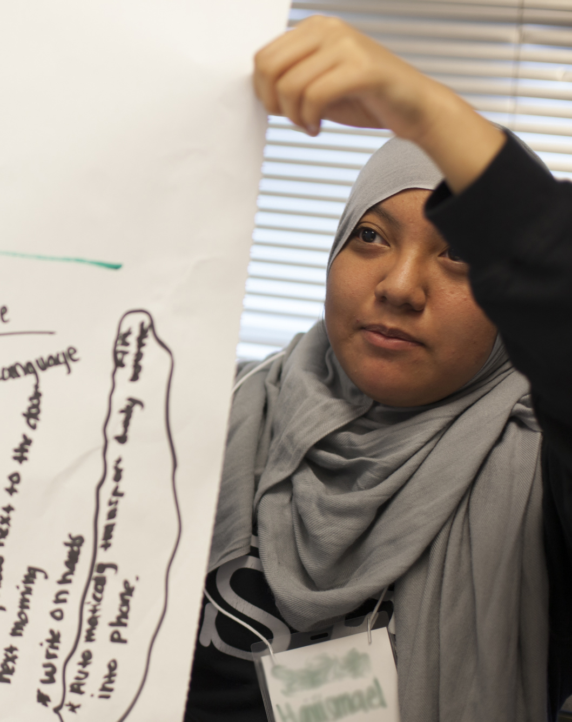 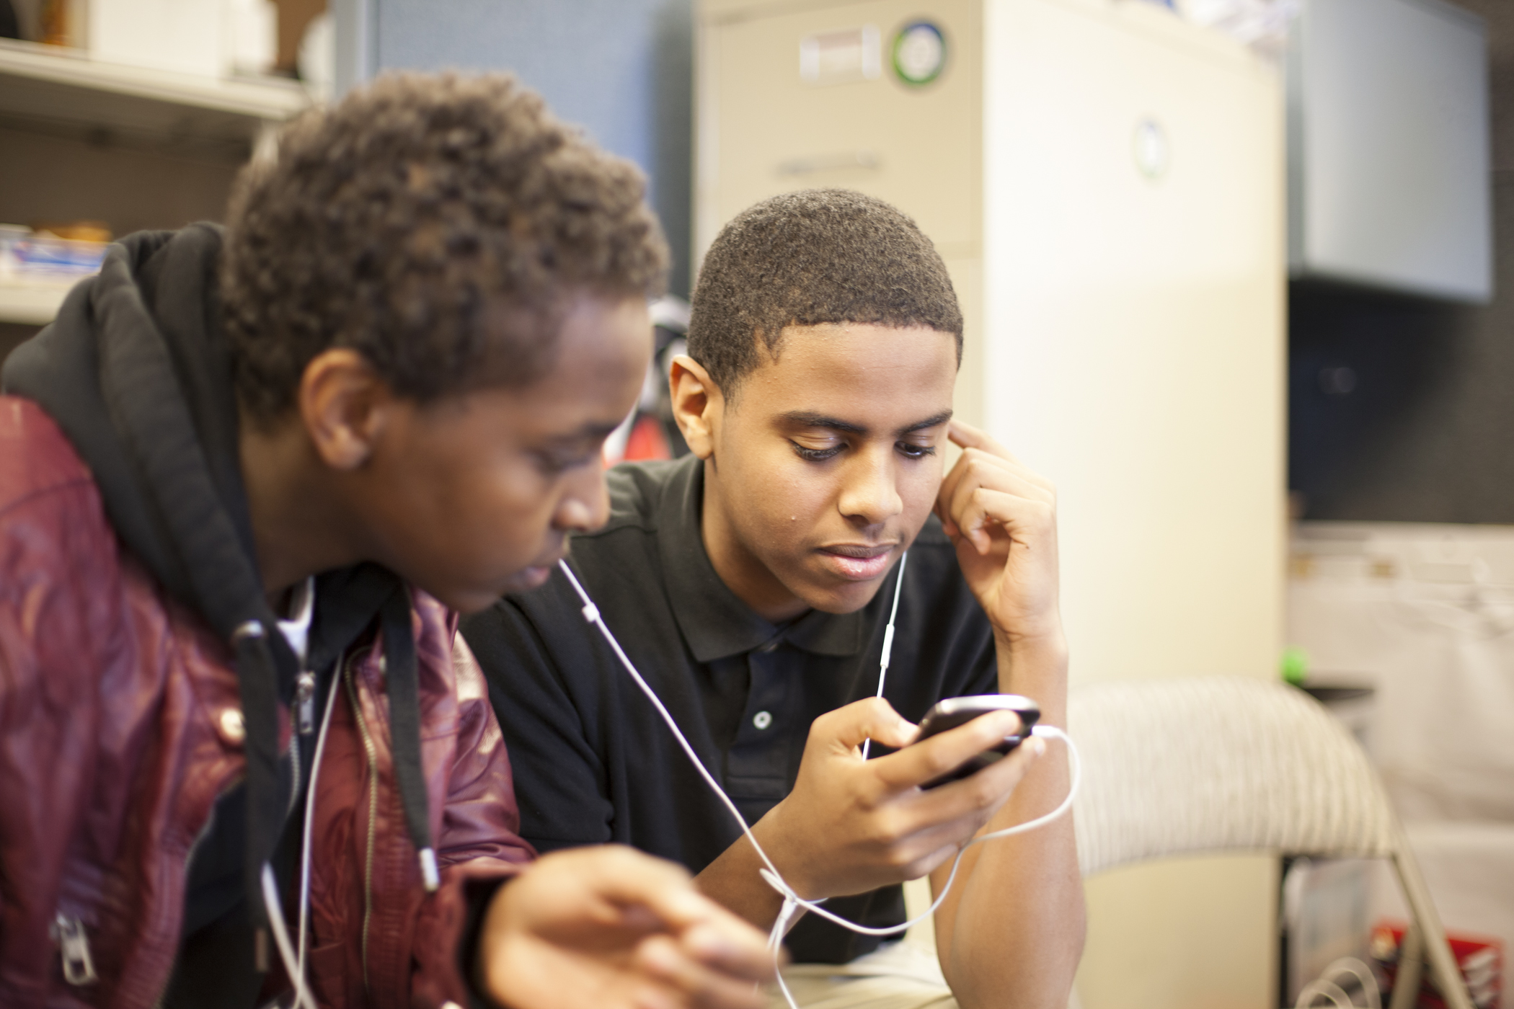

A presentation and discussion with

**Ann Peterson Bishop**

Assoc. Prof. Emerita (UI) and Research Consultant (University of Washington)

**Wednesday, Sept. 24**

**6:00-8:00 pm**

**Graduate School of LIS**

**LIS Room 131**

**501 East Daniel Street, Champaign**

**Thursday, Sept. 25**

**6:00-8:00 pm**

**One Main**

**Suite 200**

**Champaign**

Dr. Bishop will describe how the InfoMe project at UW is studying the ways immigrant and refugee youth find, remix, and share critical everyday information for their families, friends, and communities. She will focus on Teen Design Days, the methodology developed by Dr. Karen Fisher and her colleagues to involve youth in the creation of library services and digital technologies to support the teens’ information mediary work (For more information, see: <http://infome.edu>). Ann will also discuss how folks can plan and conduct their own Teen Design Days; she plans to hold a Teen Design Training Workshop with those who are interested. InfoMe is supported by the US Institute of Museum and Library Services, Microsoft Research, UW, and its community partners.

All are welcome to attend! You may contact Ann at annpbishop@gmail.com.

[](http://cdi.lis.illinois.edu/cdi/)